**PRESSURE SWING DISTILLATION OF ACETONE AND METHANOL**

**Abstract**

This report details the simulation of separating an acetone-methanol azeotropic mixture using Pressure Swing Distillation (PSD) within the COCO Simulator environment. The study aims to achieve high-purity acetone and methanol products by exploiting the pressure sensitivity of their azeotropic composition.

**1. Introduction**

Acetone and methanol are widely used solvents in various industries. Their separation is challenging due to the formation of a homogeneous azeotrope, which limits the effectiveness of conventional distillation techniques. This project explores the application of Pressure Swing Distillation (PSD) to separate the acetone-methanol azeotropic mixture, leveraging the dependency of the azeotropic composition on pressure variations. The simulation is conducted using the COCO Simulator, guided by methodologies outlined in the YouTube tutorial by Chemical Engineer with Kgabisang and supported by relevant scientific literature.

**2. Theoretical Background**

**2.1 Azeotropes and Their Challenges in Distillation**

An azeotrope is a liquid mixture that exhibits a constant boiling point and retains its composition in the vapor phase during boiling, making separation via simple distillation ineffective. The acetone-methanol system forms a minimum boiling homogeneous azeotrope, complicating their separation.

**2.2 Pressure Swing Distillation (PSD)**

PSD exploits the pressure dependency of certain azeotropes, where altering the operating pressure shifts the azeotropic composition, enabling separation. By operating two distillation columns at different pressures—one at low pressure and the other at high pressure—it's possible to circumvent the azeotropic limitation and achieve the desired separation.

**3. Methodology**

**3.1 Simulation Tool**

The COCO Simulator, an open-source chemical process simulation software, is utilized for modeling the PSD process. Its capabilities allow for the detailed representation of complex distillation sequences and the analysis of thermodynamic properties.

**3.2 Process Design**

The PSD process involves two distillation columns:

* **Low-Pressure Column (LPC):** Operates at reduced pressure (in this case: 1 bar) to shift the azeotropic composition, facilitating the initial separation.
* **High-Pressure Column (HPC):** Operates at elevated pressure (in this case: 10 bar) to further separate the components based on the altered azeotropic behavior.

**3.3 Feed Composition and Operating Conditions**

* **Feed Composition:** xMethanol = 0.5; xAcetone = 0.5
* **LPC Operating Pressure:** 0.2 bar
* **LPC Number of Stages:** 52
* **HPC Operating Pressure:** 30 bar
* **HPC Number of Stages:** 62

**3.4 Thermodynamic Model**

The Non-Random Two-Liquid (NRTL) model is employed to accurately represent the activity coefficients in the liquid phase, crucial for modeling the non-ideal behavior of the acetone-methanol mixture.

**4. Results and Discussion**The simulation results confirm that Pressure Swing Distillation effectively separates the acetone-methanol azeotropic mixture into high-purity products. The two-column system, operating at different pressures, successfully shifts the azeotropic composition, allowing separation.

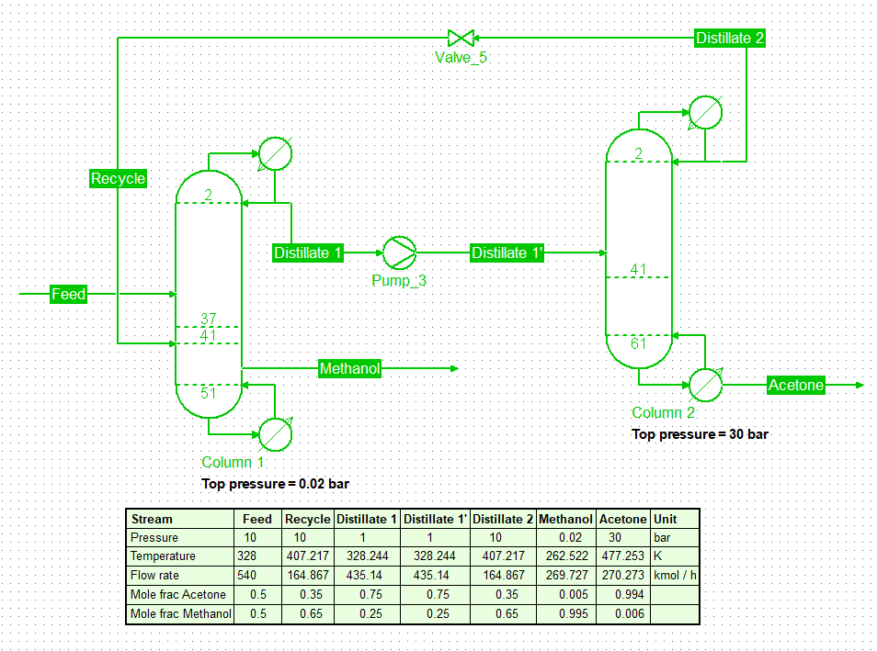

* Column 1 (Low-Pressure Column, 0.02 bar): Produces a distillate with a mole fraction of 0.75 acetone and 0.25 methanol. The bottom stream is enriched in methanol (mole fraction: 0.995).

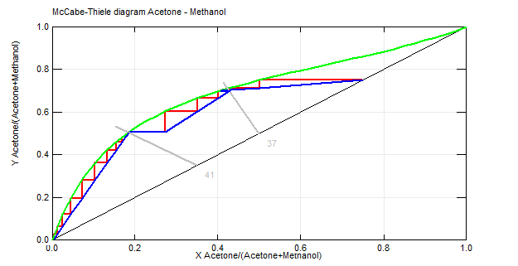

* Column 2 (High-Pressure Column, 30 bar): Receives the distillate from Column 1 and further refines it to obtain 99.4% pure acetone at the bottom.

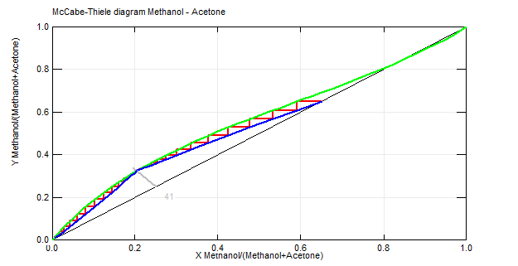

* Recycling Stream: A portion of the distillate from Column 2 is recycled to improve separation efficiency and minimize losses.

These results align with theoretical expectations and demonstrate the feasibility of using PSD for acetone-methanol separation.

**5. Conclusion**

This simulation study demonstrates the feasibility of using Pressure Swing Distillation to separate an acetone-methanol azeotropic mixture. The findings provide insights into the design and optimization of PSD processes for similar azeotropic systems.

**6. References**

* Chemical Engineer with Kgabisang. "Pressure Swing Distillation - Acetone and Methanol." YouTube
* Modla, G., & Lang, P. "Separation of an Acetone−Methanol Mixture by Pressure-Swing Batch Distillation in a Double-Column System with and without Thermal Integration." *Industrial & Engineering Chemistry Research*, 2010
* Luyben, W. L. "Comparison of Extractive Distillation and Pressure-Swing Distillation for Acetone-Methanol Separation." *Industrial & Engineering Chemistry Research*, 2008